**Project Development Phase Delivery of Sprint-2**

|  |  |
| --- | --- |
| **Date** | 07 November 2022 |
| **TeamID** | PNT2022TMID10019 |
| **ProjectName** | Analytics for Hospitals' Health-Care Data |

**Project Development Phase:**

|  |  |
| --- | --- |
| **Sprint-1:**   * Data Collection * Data Preparation   **Sprint-2:**   * Data Exploration | **Sprint-3:**   * Dashboard Creation   **Sprint-4:**   * Report Creation * Story Creation |

# 

# TEAM ID : PNT2022TMID10019

TEAM MEMBERS :

**NAVEEN KUMAR R**

**MUHAMAD TAWFEEQ**

**NARESH KUMAR**

**MUGESHKUMAR**

**Sprint-2:**

**Data Exploration:**

**> Department compared to Hospital_region_code**

**> Ward_Facility_Code for City_Code_Patient hierarchy**

**> case_id by patientid**

**> Visitors with Patient by Type of Admission**

**> Ward_Type colored by Department sized by Department**

**> Hospital_region_code for Hospital_region_code regions**

**> City_Code_Hospital by City_Code_Hospital**

**> Type of Admission by Department colored byDepartment**

**> City_Code_Hospital by Department> Ward_Type for Ward_Facility_Code**

**Department compared to Hospital_region_code:**

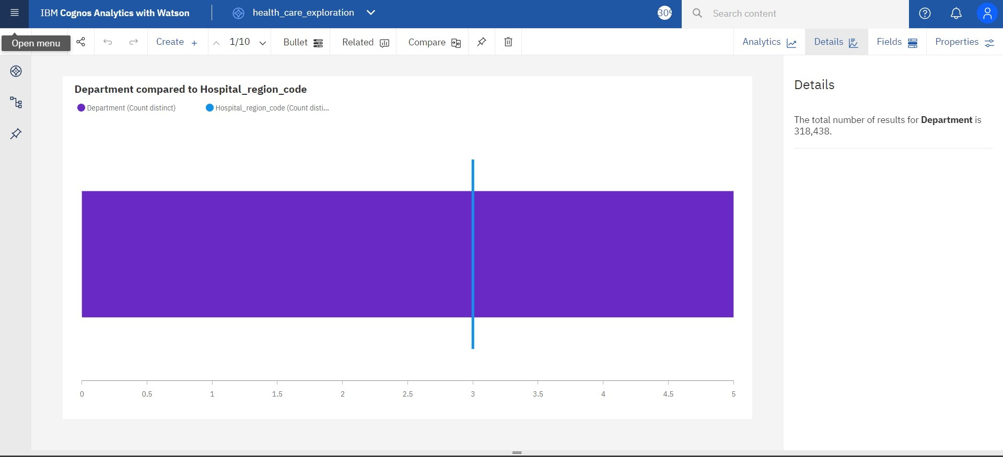

**Ward_Facility_Code for City_Code_Patient hierarchy:**

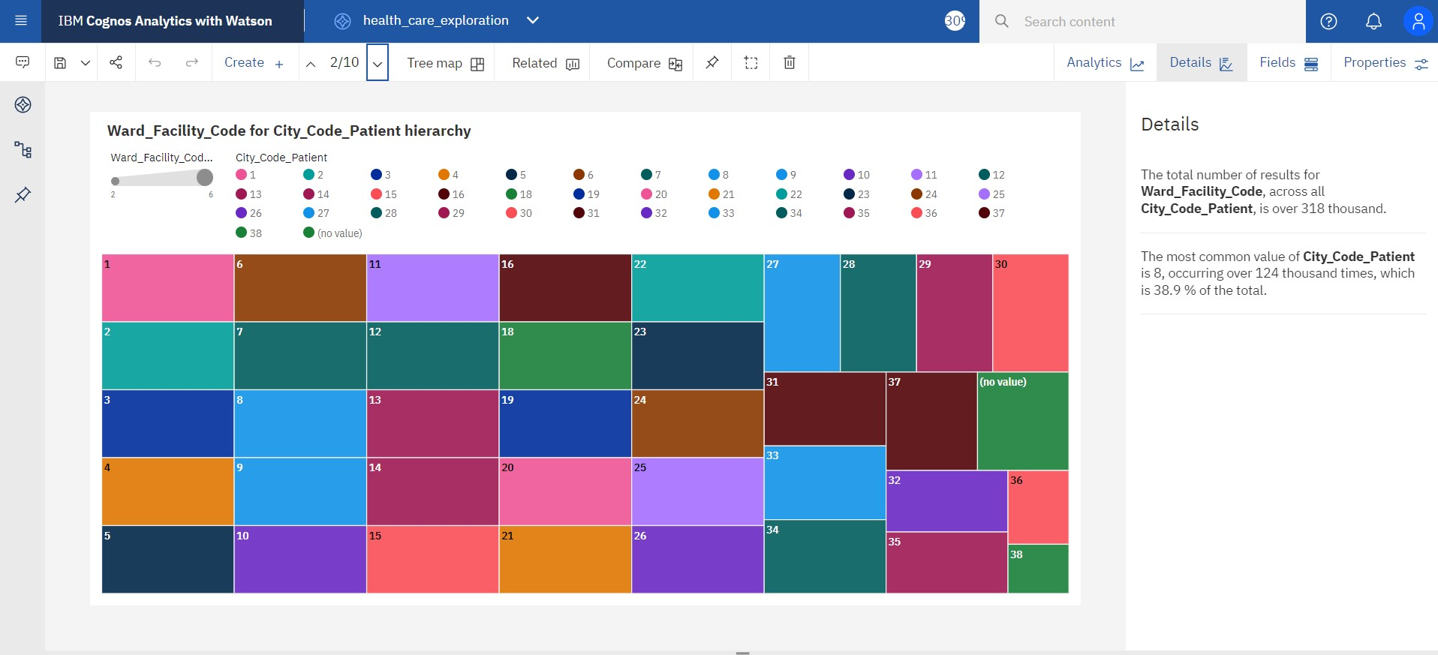

**case_id by patientid:**

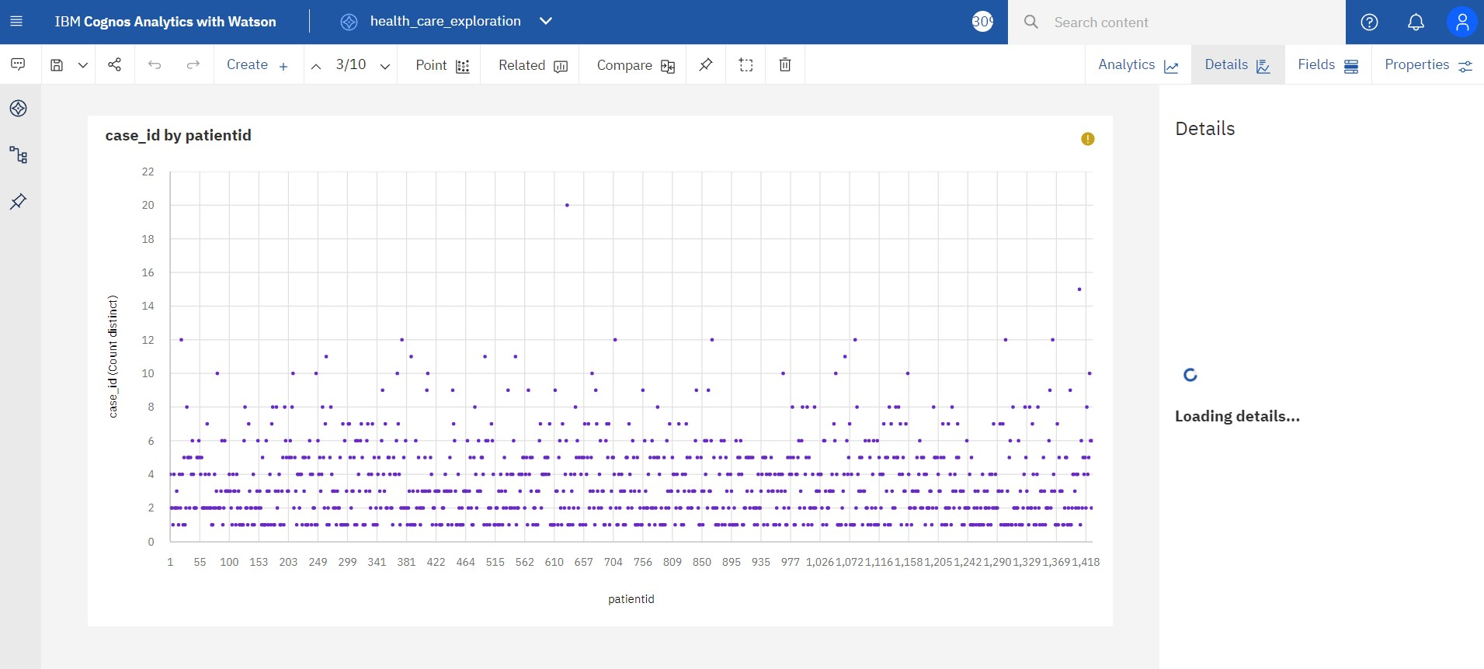

**Visitors with Patient by Type of Admission:**

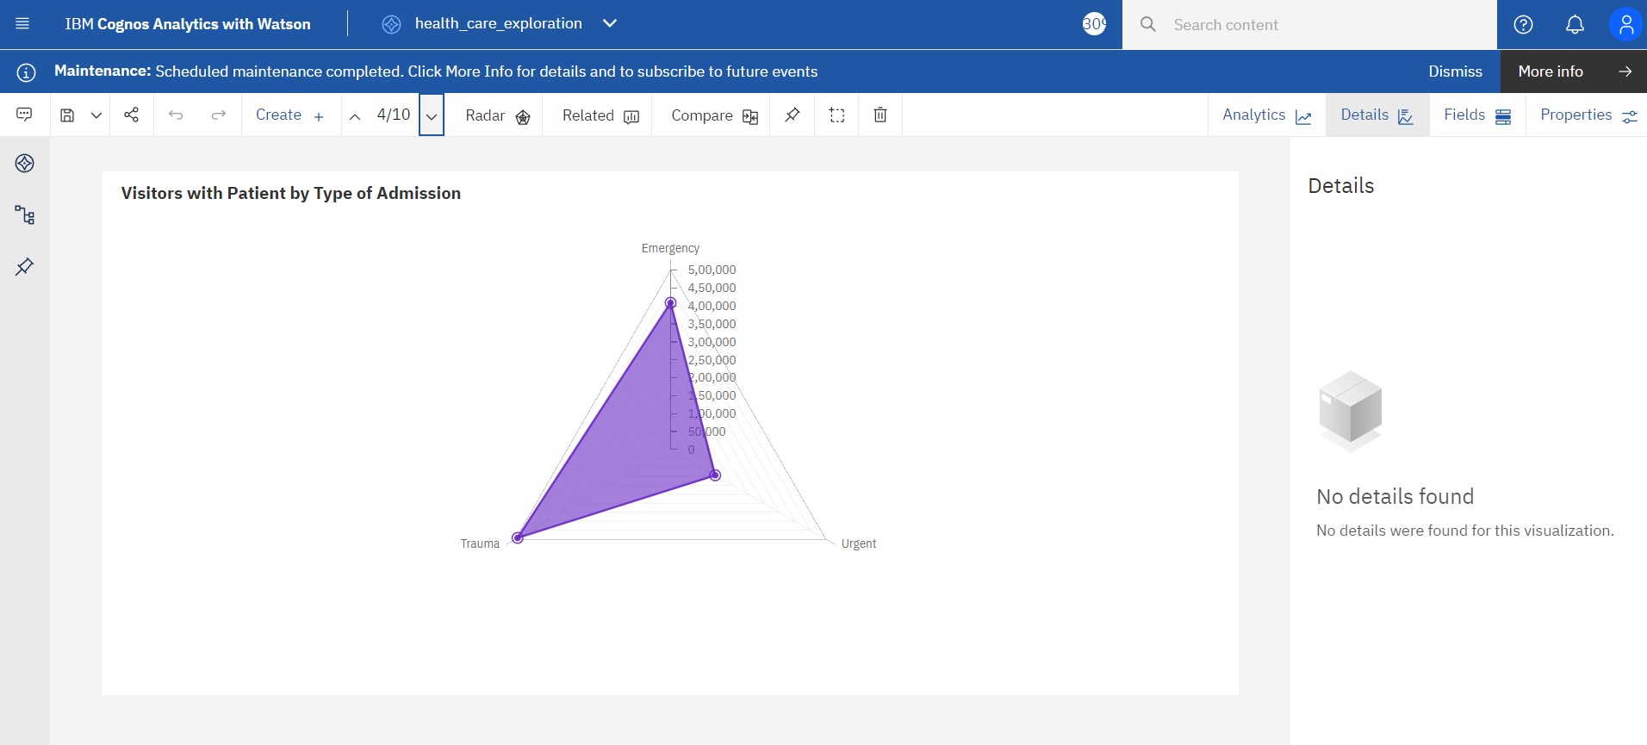

**Ward_Type colored by Department sized by Department:**

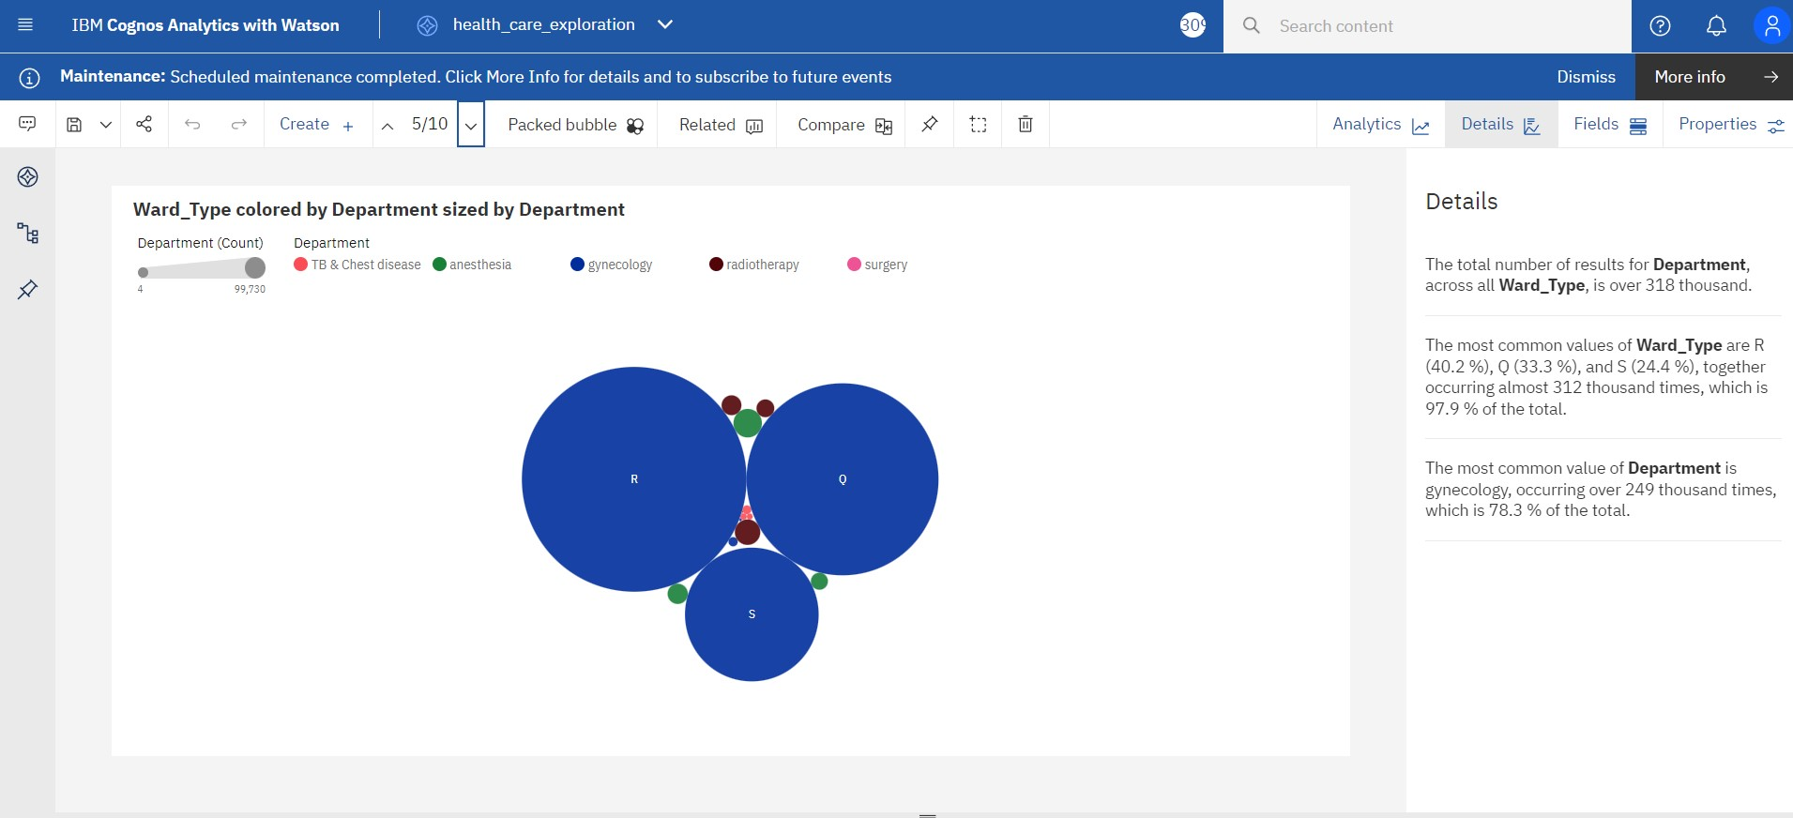

**Hospital_region_code for Hospital_region_code regions:**

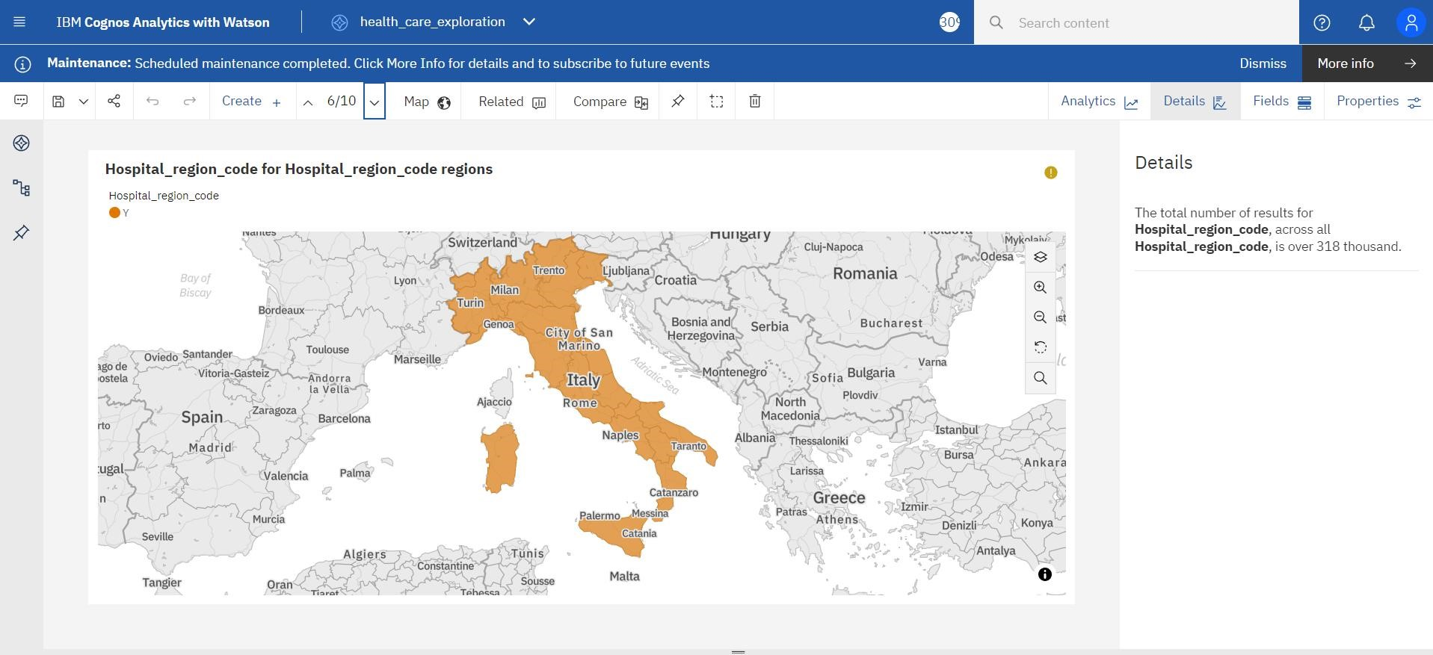

**City_Code_Hospital by City_Code_Hospital:**

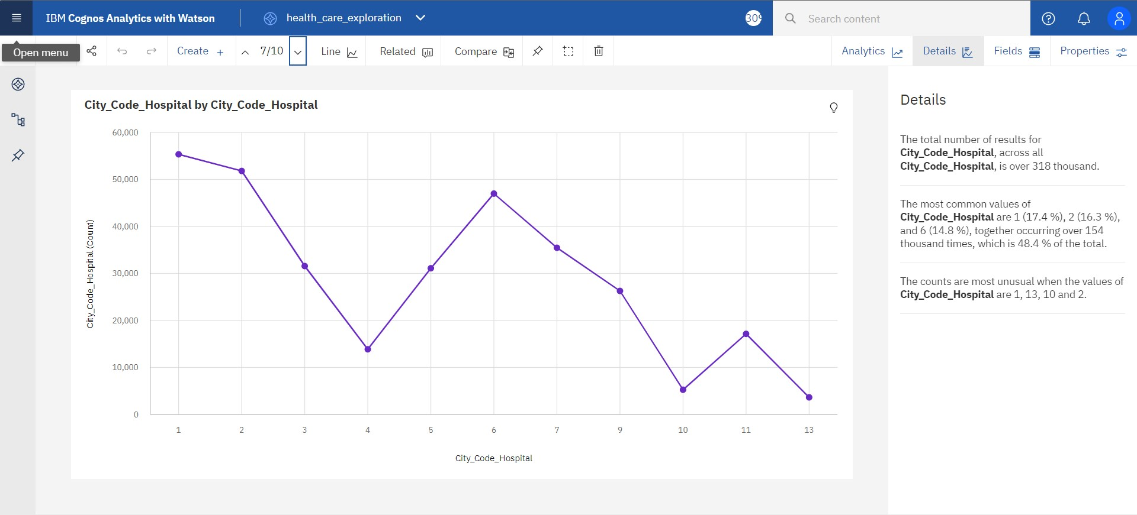

**Type of Admission by Department colored by Department:**

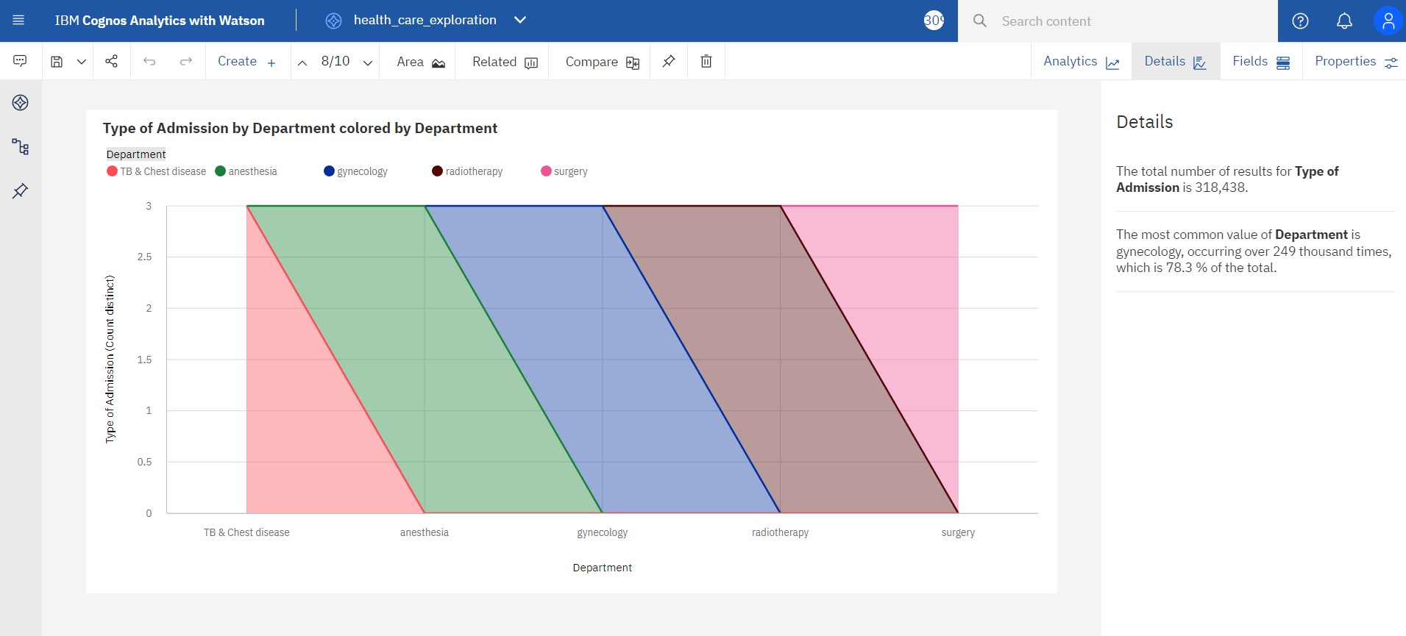

**City_Code_Hospital by Department:**

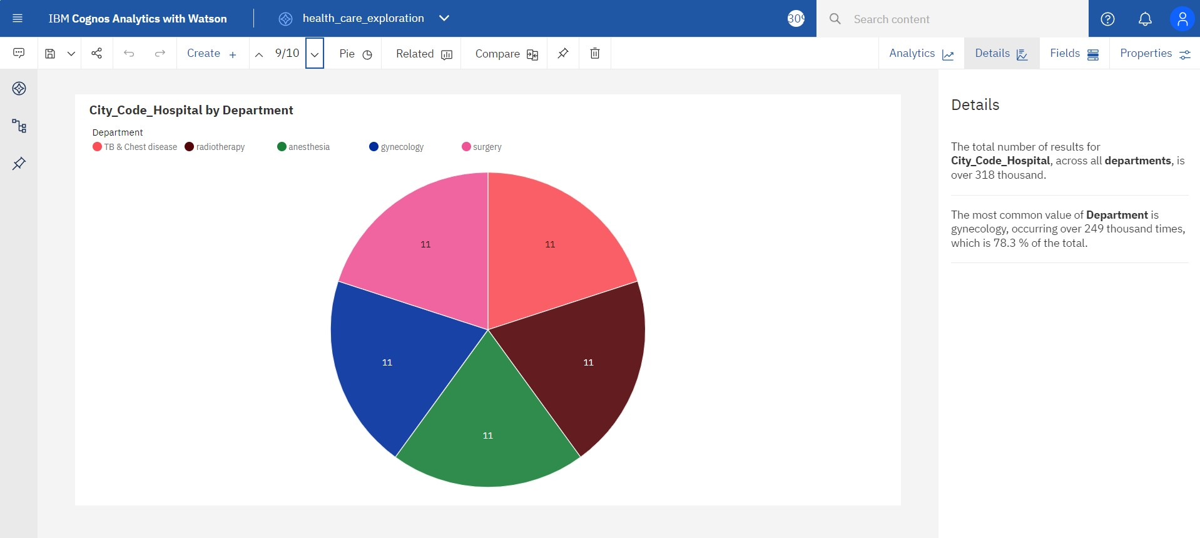

**Ward_Type for Ward_Facility_Code:**

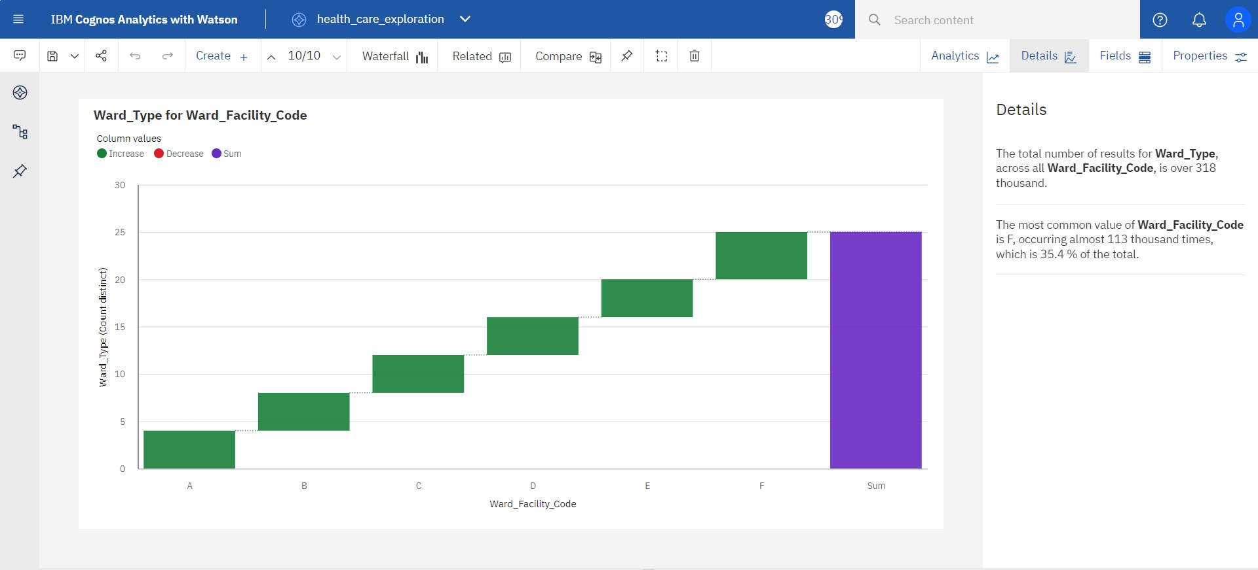

**Prepared data link :**

 https://us3.ca.analytics.ibm.com/bi/?perspective=explore&pathRef=.my_folders%2Fdata_exploration%2F health_care_exploration&subView=model000001844

10946c6_00000000